Developed By Smartrix Technologies
Finance Software (FinSoft)Requirements Specifications
Version 1.1

Author : Shekhar G. Wagh
11/8/2013

Introduction
Finance Software(FinSoft) is a Web based finance application for investers to enter and track their investment information, receive reminders and access general finance information. FinSoft will offer different investment schemes/packages with differing returns.
The long term goal of FinSoft is to attract investors from references to its different investment schemes , provide returns/yields calculators on the spot , collect payment(investment amount) online by integrating FinSoft with Payment Gateway Service , generate different MIS reports like investment amount receipts, ledger, cash balance on monthly/yearly basis & despatch returns payment.
The scope of the total FinSoft development is anticipated to be implemented in stages over a period of 3 months. It is the intention of the company to develop and market FinSoft at this time while providing the underlying investment data sharing, referral ID and other common aspects of future releases to incorporate additional user types & investment schemes.

The Version 1.0 of the FinSoft system is base data information & shall have the following features:
- Schemes – Information of fixed return scheme with annual interest at rate of 13% plus referral commission of 2% for 6 month scheme and 3% for one year scheme. Calculator shall be provided to calculate returns for different amounts based on above interest rate.
- My Profile – General investor information
- Contacts – People to contact
- Referal Code Generation –Code of the referring person for the investor
- Success Stories – Stories of investors who have already benefitted from different investment schemes.
- Testimonials – Quotes from the investors already investing in different schemes.
- Investment payment – Integration with Payment Gateway Service Provider for online payment.
- Returns payment – Online returns payment to the investors & it’s records .
- Returns Confirmation – Online confirmation by the investors about receipt of returns payment.
- Returns/Yield Calculator -- Online Calculator of Returns/Yield for fixed return scheme.
- Balance Report – Monthly/Yearly available Account Balance 2 days before end of month/year
- TDS Deductions – for PAN Card holders 10% , for others 20% of total returns
- Referral(Broker) Commision Report – Referal commission report as per terms & conditions with TDS deduction.
- Cheque Issuance & its tracking .
- Pending Cheque Report
- Bounce Cheque Report
- Mobile/Email Alerts Module to both Investors.
- Investors Classification national/international.
- Investment of 50,000 rs minimum upto 25 lakhs maximum shall be accepted
- Investment will be received for expansion of Kakaria group of companies.Hence no other borrower is required.
- Investors cheques shall be couriered or epayment mode shall be accepted.Invetor address for cheque payment shall be captured.
- On investment payment confirmation by the investor,system will generate payment terms and conditions plus agreement copy (promisary note).
- System shall provide facebook and youtube integration.
- Login id shall be pan no of the investor.
- Admin shall upload portfolio details of Kakaria group of companies.This shall be displayed to the investor.
References

www.micrograam.com
www.seedstogether.org
www.nalandacapital.com

Main Functions(Screen Pages):

Default / Landing Page

Screen
- Should display Pratap Sir’s Photo
- Should display content of investment benefits to investors through our company
- Should capture the following investor information :
- User ID (mandatory)
- Password(mandatory)
- Referral Code(not mandatory)
- Email Address(not mandatory)
- Tel. No.(mandatory)
- Pan No(not mandatory)
- Enter button to go ahead.

2nd Page

Screen
1. Should display different investment schemes selection links
2. Should display success stories content
3. Should display Testimonials
4. Should display contact details of our company.
5. Should display calculator link for different investment schemes.

3rd Page(Individual Scheme Page)

Screen
1. Should display details of investment scheme
2. Should display payment option link.
3. Should connect to payment gateway
4. Should display calculator link for that investment scheme.
5. Should capture Bank details of the investor.

Use Case Template
Project Name: Financial software (FinSoft)

Date: September 30, 2014

Use Case List 1

Use Case ID | Primary Actor | Use Cases | Developer
1.1 | Investor | Investor Registration.(Sign Up) Use Case | Tanvi
1.2 | Investor | Investor Login Use Case | Vinod
1.3 | Investor | Investors Online Investment Use Case | Prashant
1.4 | Investor | Investment Tracking Use Case | Sunita
1.5 | Investor | Investor issues and complaints. Use Case | Rudra

Use Case List 2

Use Case ID | Primary Actor | Use Case | Developer Name
2.1 | Admin | Admin Login Use Case. | Vivek
2.2 | Admin | Handling Investors Cheque Logistic Use Case | Vinod
2.3 | Admin | Handling Company’s Cheque ,DD, Online Payment Logistic Use Case | Tanvi
2.4 | Admin | Handling investors issues and complains Use Case | Rudra
2.5 | Admin | Updating Testimonials Use Case | Tejashree

Main Use-Case:
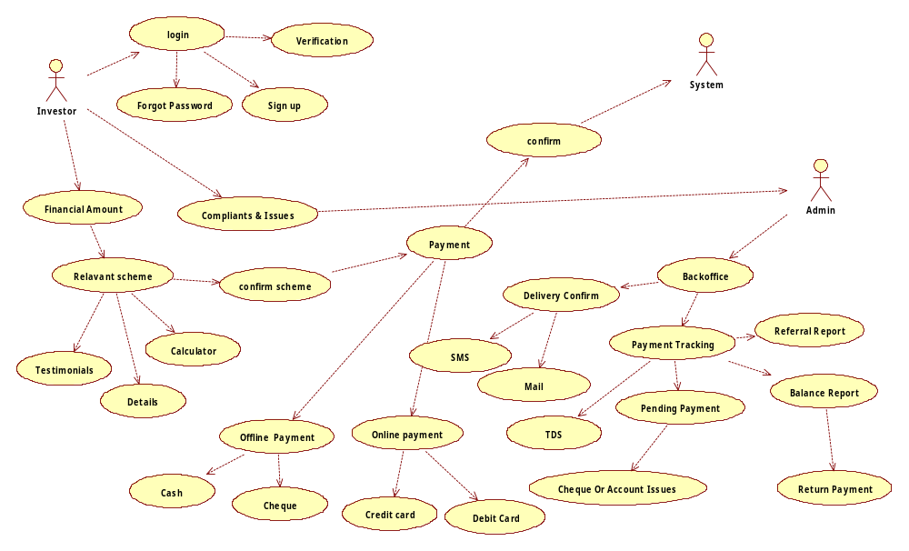

1) Feature Name Fin Soft

1.1.) Feature Process Flow / Use Case Model

Use Case(s)
Use Case ID: |  | U.C.1.1
Use Case Name: |  | Investor Registration.(Sign Up) Use Case
Created By: | Prashant More |  |  | Last Updated By: | Prashant More
Date Created: | 10/03/2014 |  |  | Last Revision Date: | 10/03/2014
Actors: |  |  | Financial Investor  Participating actors:  System
Description: |  |  | Flow 1  1)Enter full name*  2)Enter User id(PAN number)*  3)Enter Email ID*  4)Enter password*  5)Confirm password*  6) Redirect to Login Page.  Flow 2  1)Enter User id(PAN number)*  2)Enter password*  3) Before making payment capture the following data  4) Investor Profile.  5)Enter Referral ID  6)Enter Email ID*  7)Enter Mobile phone number*  8)Bank Account Details*  .1)Account Number  .2)Account Type  .3)IFSC Code  .4)Bank Name  .5)Bank Branch  9) Submit.  10) Profile Complete.
Trigger: |  |  | Click Sign Up Link
Preconditions: |  |  | 1)Investor must have PAN Number or Form 15G*  2) Password should have minimum six character and 1 lower case and 1 uppercase and 1 special character-  4)Enter valid Email ID*  5)valid Mobile phone number*  6)Valid PAN Number  7) Valid Bank Account Details
Post conditions: |  |  | 1) Confirmation of registration from system by Mobile and Email alerts.  2) Redirect to login page
Normal Flow: |  |  | Flow 1  1)Enter full name*  2)Enter User id(PAN number)*  3)Enter Email ID*  4)Enter password*  5)Confirm password*  6) Redirect to Login Page.  Flow 2  1)Enter User id(PAN number)*  2)Enter password*  3) Before making payment capture the following data  4) Investor Profile.  5)Enter Referral ID  6)Enter Email ID*  7)Enter Mobile phone number*  8)Bank Account Details*  .1)Account Number  .2)Account Type  .3)IFSC Code  .4)Bank Name  .5)Bank Branch  9) Submit.  10) Profile Complete.
Alternative Flows: |  |  | If already registered then login.
Exceptions: |  |  | 1)Investor will be rejected without PAN Number  3) Entered Password should have minimum six characters and 1 lower case and 1 uppercase and 1 special character.  4) Entered Email ID, Bank Account Details should be valid.  5) Entered Mobile phone number should be valid.  6) Investor will be rejected without acceptance of T&C.
Includes: |  |  | system software
Frequency of Use: |  |  | 20 per day
Special Requirements: |  |  | PAN Number
Assumptions: |  |  | 1)Investor must have Valid PAN Number  2) User id, password Satisfying preconditions.  3) telephone no  4)Email id  5) Bank Account.
Notes and Issues: |  |  | 1)Password should have minimum six character and 1 lower case and 1 uppercase and 1 special character-  2)valid referral id

Figure 1.1.Investor registration Use Case

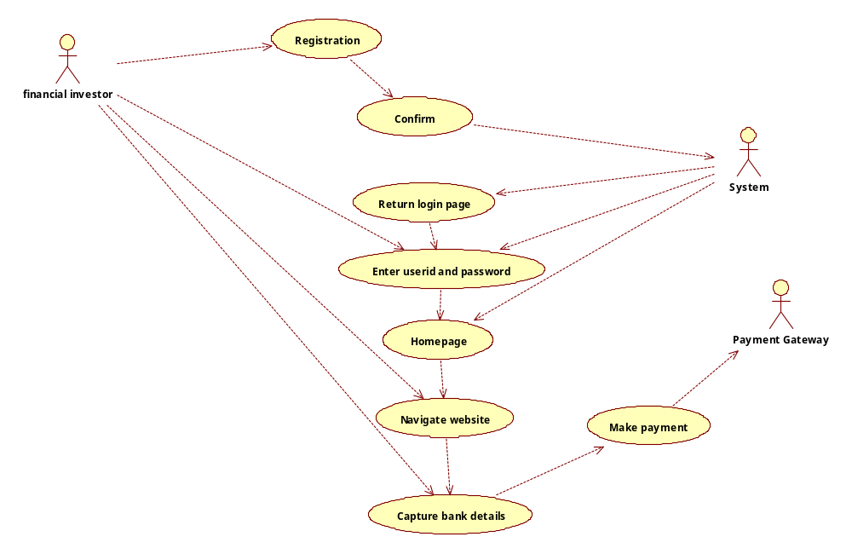

Feature Name FinSoft

1.2) Feature Process Flow / Use Case Model

Use Case(s)
Use Case ID: | U.C.1.2
Use Case Name: | Investor Login Use Case
Created By: | Prashant More |  | Last Updated By: | Prashant More
Date Created: | 10/03/2014 |  | Last Revision Date: | 10/03/2014
Actors: |  | Financial investor  Participating actors:  System
Description: |  | 1) Login in Investor in after registration  2) Entering valid username (PAN Number)/password.  3 )interacting with system  4)Logging in the Investor
Trigger: |  | Login of investor (clicking on login button).
Preconditions: |  | 1)Investor Should be Registered  2) Investor must have Valid Username(PAN Number) and Password
Post conditions: |  | Redirect to home page
Normal Flow: |  | 1)Investor access login page  2) Enters Valid Username (PAN Number) and password.  3) Logs in
Alternative Flows: |  | Redirect to Register Page.  Redirect to Login Page  Forget password
Exceptions: |  | 1)username Invalid(PAN Number)  2)Password Invalid
Includes: |  | system software
Frequency of Use: |  | 50 per day
Special Requirements: |  | Investor Should be Registered first.
Assumptions: |  | Investor is registered with valid username (PAN Number)/password.
Notes and Issues: |  | Unauthorized Access by user with invalid Username (PAN Number)/password.

Figure 2.Investor login Use Case
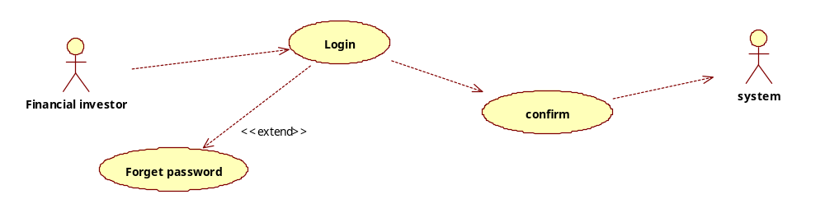

Feature Name FinSoft

1.3)Feature Process Flow / Use Case Model

Use Case(s)
Use Case ID: |  | U.C.1.3
Use Case Name: |  | Investors Online Investment Use Case
Created By: | Prashant More |  |  | Last Updated By: | Prashant More
Date Created: | 10/03/2014 |  |  | Last Revision Date: | 10/03/2014
Actors: |  |  | Financial Investor  Participating actors:  System  Admin.
Description: |  |  | !) enter amount to invest(Rs50,000-25,00000)  2) Displays schemes relevant to that amount.  3) Read Testimonials and Schemes details. Requests for Portfolio.  4) Live Finance Calculator for scheme calculations and return  5) Confirm Scheme  6)Login  7) Read Penalty details, Terms and Conditions, Cancelation and validation details.  .8) Select Payment Mode.  9) Enter valid Transaction details.(check out screen)  10) Make Payment.(Redirect to payment gateway)  11) Receive Confirmation (SMS and Email) from Admin.and Bank.
Trigger: |  |  | Login and select amount to Invest.
Preconditions: |  |  | 1) Investor should be registered. And Logged in.  2) Investor must have read all the details and terms of conditions before confirmation of scheme.  3) Investor should have valid Transaction details (card/bank details/cheque) to make payment.
Post conditions: |  |  | Investor Must receive confirmation after making the payment through Mobile/Email alerts.
Normal Flow: |  |  | 1) Select Scheme.  2) confirm scheme  3)Logs in  4) Make Payment.
Alternative Flows: |  |  | .1) Investor can Select more than one Scheme to invest.  2) Investor can make payment through online and offline mode
Exceptions: |  |  | - Investor is not logged in.  - Amount not entered  - Scheme not selected  - Terms & Conditions not accepted.  - Invalid Transaction Details
Includes: |  |  | system software and Admin.
Frequency of Use: |  |  | 20 per day.
Special Requirements: |  |  | Valid transaction Details.
Assumptions: |  |  | 1) Investor should be registered. And Logged in.  2) Investor must have read all the details and terms of conditions before confirmation of scheme.  3) Investor should have valid Transaction details (card/bank details/cheque) to make payment.
Notes and Issues: |  |  | 1) Investor can invest in more than one scheme with the same registration id.  2) Investor can use different bank accounts to make payments as well as receive payments.

Figure 3.Investor actual online investment Use Case
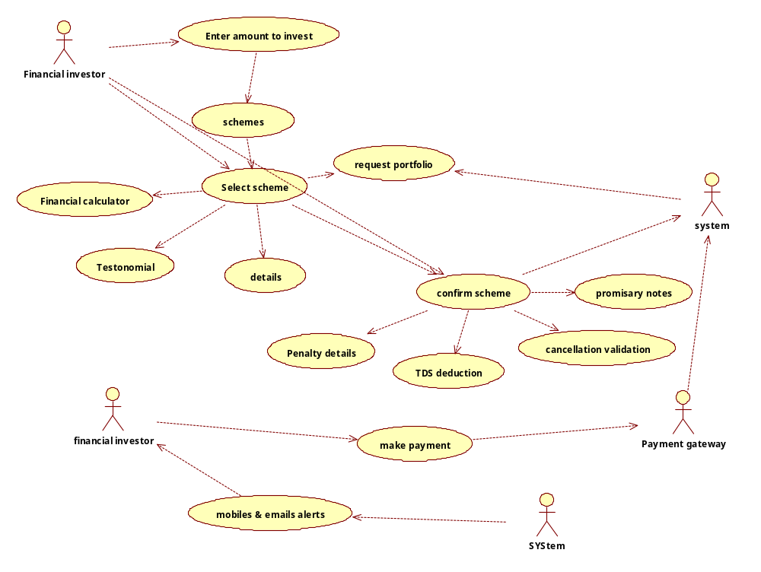

Feature Name FinSoft

1.4)Feature Process Flow / Use Case Model

Use Case(s)
Use Case ID: |  | U.C.1.4
Use Case Name: |  | Investment Tracking Use Case
Created By: | Prashant More |  |  | Last Updated By: | Prashant More
Date Created: | 10/03/2014 |  |  | Last Revision Date: | 10/03/2014
Actors: |  |  | Financial Investor  Participating actors:  System  Admin
Description: |  |  | !) Login  2) Request current return Details./Balance details.  3) If return payment received give confirmation.  3.1)IF received by online Then confirm by Email  3.2)IF received by courier Then Email/SMS.
Trigger: |  |  | Clicking Track Investment link
Preconditions: |  |  | - Investor should be registered. And Logged in.  - Investor should have made an investment in particular scheme to track its investment.
Post conditions: |  |  | Receives scheme Portfolio.  Receives current return details
Normal Flow: |  |  | 1)User Logs in with valid username (PAN Number)and password  2) Clicks Track Investment link.  3) Requests for Portfolio.  4) Request current return Details/balance details.  5) If return payment received give confirmation.
Alternative Flows: |  |  | Investor can directly view current return details.
Exceptions: |  |  | - Investor Should be logged in .  - Investor can only track for Investment if he has invested.
Includes: |  |  | system software and Admin.
Frequency of Use: |  |  | 50 per day.
Special Requirements: |  |  | Balance report of Monthly/Yearly available Account Balance
Assumptions: |  |  | Investor is registered, and investor has invested in the Scheme.
Notes and Issues: |  |  | - Balance Report – Monthly/Yearly available Account Balance end of month/year  - Investor can interact with Admin to know about TDS Deductions in the return payment.

Figure 4.Investor investment tracking Use Case

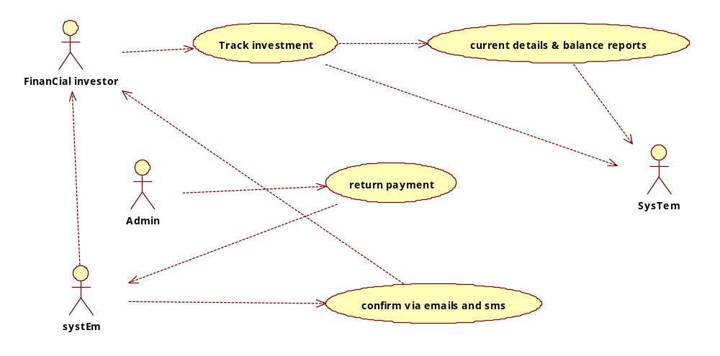

Feature Name FinSoft

1.5)Feature Process Flow / Use Case Model

Use Case(s)
Use Case ID: |  | U.C.1.5
Use Case Name: |  | Investor issues and complaints. Use Case
Created By: | Prashant More |  |  | Last Updated By: | Prashant More
Date Created: | 10/03/2014 |  |  | Last Revision Date: | 10/03/2014
Actors: |  |  | Financial Investor  Participating actors:  System  Admin
Description: |  |  | !) Login  2) Report Complaints.  3) Reports Issues.
Trigger: |  |  | Clicking report button/link
Preconditions: |  |  | 1)Investor should be registered.  2) Investor should be Logged In.
Post conditions: |  |  | Confirmation of Issue Submitted to system.  Confirmation of Issue Solved from admin..
Normal Flow: |  |  | 1)User Logs in with valid username (PAN Number)and password  2) Report issues and complaints to Admin Through System.  3) Admin responds Back to the Investor through system.
Alternative Flows: |  |  | 1)Login Issues  1.1)Forget Id  1.2)Forget Password  2) If Issues still persist Then Directly contact the Admin through physical communication.
Exceptions: |  |  | 1)Investor Should be logged in to report an issue or complaint.  2) Investor should only report issues through System first.
Includes: |  |  | system software and Admin.
Frequency of Use: |  |  | 20 per day.
Special Requirements: |  |  | Valid Username (PAN Number)and Password..
Assumptions: |  |  | Investor is registered with valid username (PAN Number)and password.
Notes and Issues: |  |  | 1) Valid Username(PAN Number).  2)Password should have minimum six character and 1 lower case and 1 uppercase and 1 special character-

Figure 5.Investor issues and complaints
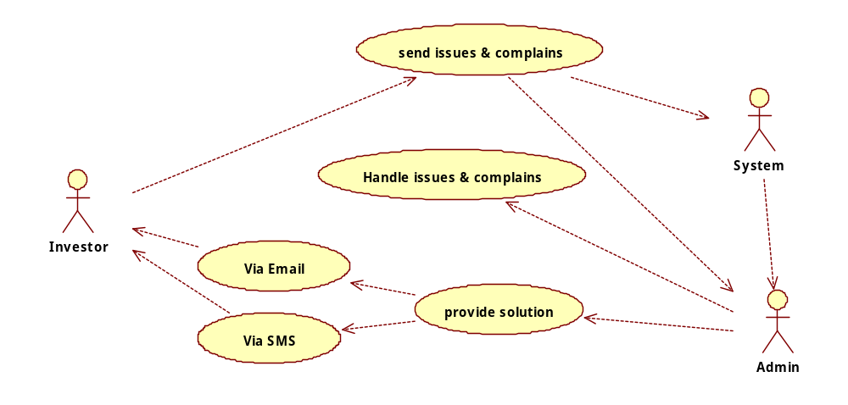

Feature Name FinSoft

2.1) Feature Process Flow / Use Case Model

Use Case(s)

Use Case ID: |  |  | U.C. 2.1
Use Case Name: |  |  | Admin Login Use Case
Created By: |  |  |  | Last Updated By:
Date Created: |  |  |  | Last Revision Date:
Actors: | Back Office Admin  Participating actors:  System
Description: | 1)Enter User ID  2)Enter password  7)login
Trigger: | Click Login
Preconditions: | 1) Admin must enter correct user id  2)Admin must enter correct password
Post conditions: | Performs back office work (Refer UC 2.2)
Normal Flow: | 1)enter login details  2) Performs back office work
Alternative Flows: | NONE
Exceptions: | 1) Invalid username, password.
Includes: | System & Admin
Frequency of Use: | 500 per day
Special Requirements: | Admin id and password
Assumptions: | 1)Admin has id and password.
Notes and Issues: | 1)Username is CASE SENSITIVE  2)Password is CASE SENSITIVE  3)Unauthorized Access by particular user with invalid Username/password limited up to maximum 10 times a day.

Figure 6:ADMIN LOGIN USE CASE
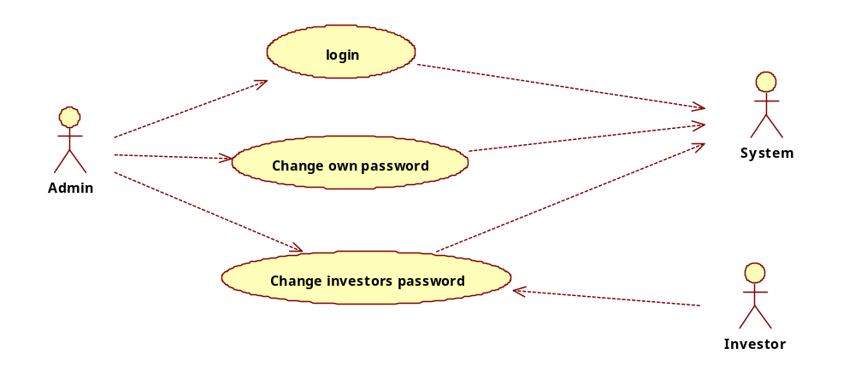

Feature Name FinSoft

2.2)Feature Process Flow / Use Case Model

Use Case(s)
Use Case ID: | 2.2
Use Case Name: | Handling Investors Cheque Logistic Use Case
Created By: |  |  | Last Updated By: | 13/03/2014
Date Created: | 10/3/2014 |  | Last Revision Date: | 13/03/2014
Actors: |  | Admin  Participating actors:  System  Financial investor
Description: |  | - Receive Cheque/Demand Draft Details ( Bank Name ,Date, Amount) From Valid Investor  - Check if details are valid or not  - Submit Cheque/ Demand Draft to the Bank.  - Status of cheque/ Demand Draft (Pending/ cleared/ bounced/recovery).  - If cheque/ Demand Draft is cleared/ bounced notify the Investor.  - Generate pending/cleared/bounce/recovery report.
Trigger: |  | Selected payment mode as Cheque/ Demand Draft.
Preconditions: |  | 1) Investor must be registered.  2) Investor issued a cheque/ Demand Draft.
Post conditions: |  | Acknowledgement of Cheque/ Demand Draft .
Normal Flow: |  | - Investor issued a cheque/ Demand Draft.  2)Receive Cheque/ Demand Draft Details ( Bank Name ,Date, Amount) From Valid Investor  3)Check if details are valid or not  4)Submit Cheque/ Demand Draft to the Bank  5)Status of cheque/ Demand Draft (pending/cleared/bounce/recovery).  6)If cheque is cleared/ bounced notify the Investor.  7) Acknowledgement of Cheque/ Demand Draft Details.  8)Generate pending/cleared/bounce/recovery report.
Alternative Flows: |  | If Invalid Cheque/ Demand Draft details then Notify the Investor.
Exceptions: |  | Invalid cheque / Demand Draft details.
Includes: |  | System software,Admin , Investor.
Frequency of Use: |  | -
Special Requirements: |  | Registered Investor
Assumptions: |  | 1) Registered Investor  2) Valid issued cheque/ Demand Draft details
Notes and Issues:

Figure 7: ADMIN HANDLING INVESTORS CHEQUE LOGISTICS Use Case
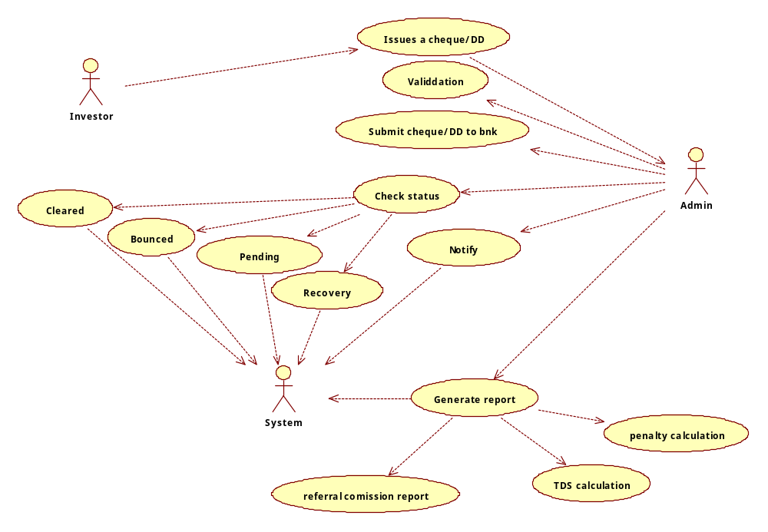

Feature Name FinSoft

2.3)Feature Process Flow / Use Case Model

Use Case(s)
Use Case ID: | 2.3
Use Case Name: | Handling Company’s Cheque ,DD, Online Payment Logistic Use Case
Created By: |  |  | Last Updated By: | 13/03/2014
Date Created: | 10/3/2014 |  | Last Revision Date: | 13/03/2014
Actors: |  | Admin  Participating actors:  System  Financial investor
Description: |  | 1) Check Balance Report for issuing cheques/ Demand Draft/Online Payment.  2)Issuing Cheque Details / Demand Draft /Online Payment( Investor Name, Bank Name ,Date, Amount) From Company  3)Check if details are valid or not  4) Dispatch Cheque/DD to the investor or make Online Payment..  5) Receive Acknowledgement from Investor.  6) Status of Online Payment/cheque/ Demand Draft (Confirmed/pending/cleared/bounce/recovery).  7) Notify the Investor through system..
Trigger: |  | Before Month/Year End
Preconditions: |  | Check Balance Report for issuing cheques.
Post conditions: |  | Issuing Cheque / Demand Draft Details  Notify the Investor
Normal Flow: |  | 1) Check Balance Report for issuing cheques/ Demand Draft.  2)Issuing Cheque/ Demand Draft Details ( Investor Name, Bank Name ,Date, Amount) From Company  3)Cheque number is checked.  4)Cheque issue date is checked.  5)IFSC code is checked.  6) Status of cheque / Demand Draft (Confirmed/pending/cleared/bounce/recovery).  7) Get the image of cheque by scanning it.
Alternative Flows: |  | If Payment mode is Offline.
Exceptions: |  | Invalid Investors Bank details.  NO pending Payments.
Includes: |  | System software, Admin, Investor.
Frequency of Use: |  | -
Special Requirements: |  | Investors Details
Assumptions: |  | - Registered Investor  - Pending Payment to the Registered Investor.
Notes and Issues:

Figure 8: ADMIN HANDLING COMPANY'S CHEQUE & ONLINE PAYMENT LOGISTICS Use case
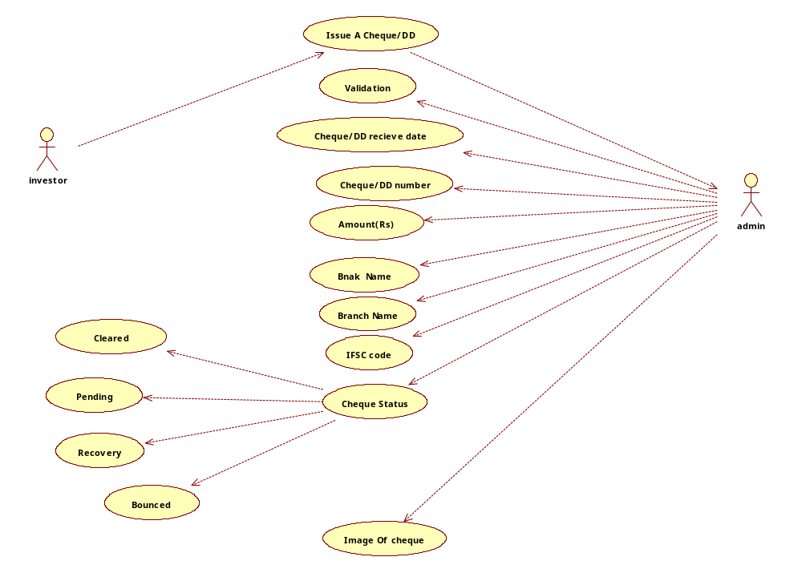

Feature Name FinSoft

2.4)Feature Process Flow / Use Case Model

Use Case(s)
Use Case ID: | 2.4
Use Case Name: | Handling investors issues and complains Use Case
Created By: |  |  | Last Updated By: | 13/03/2014
Date Created: | 10/3/2014 |  | Last Revision Date: | 13/03/2014
Actors: |  | Admin  Participating actors:  System  Financial investor
Description: |  | 1) Check issue/complain of valid investor  2) Provide solution.
Trigger: |  | Arrival of issue/complain
Preconditions: |  | Investor must be registered.
Post conditions: |  | Provide solution via system or e mail and massage alert.
Normal Flow: |  | - Getting issue/complain from investor’s profile.  - Handling current issue/complain.  2) Provide Solution through email and SMS to investor.
Alternative Flows: |  | If problem still persists then directly contact the Admin through  Physical communication.
Exceptions: |  | 1)Invalid issues/complains  2) Invalid investor contact details.
Includes: |  | System software , Investor
Frequency of Use: |  | 200 per day
Special Requirements: |  | Valid admin
Assumptions: |  | 1) Registered Investor  2) Valid issue/complain.
Notes and Issues:

Figure 9: ADMIN HANDLING INVESTORS ISSUES & COMPLAINS Use Case

Feature Name FinSoft

2.5)Feature Process Flow / Use Case Model

Use Case(s)
Use Case ID: |  |  | 2.5
Use Case Name: |  |  | Updating Testimonials Use Case
Created By: |  |  |  | Last Updated By: | 13/03/2014
Date Created: |  | 10/3/2014 |  | Last Revision Date: | 13/03/2014
Actors: | Back office Admin  Participating actors:  System
Description: | 1)Receive Inventors testimonial, Videos , Portfolios  2)Upload Testimonial  3)Confirmation for received testimonial.
Trigger: | Receive Testimonial
Preconditions: | 1)Valid investor  2)Valid Testimonial
Post conditions: | Upload /update testimonial
Normal Flow: | 1)Receive Inventors testimonial  2)Upload Testimonial
Alternative Flows:
Exceptions: | Invalid investor
Includes: | system software
Frequency of Use: | 100 per day
Special Requirements: | None
Assumptions: | 1)Valid investor  2)Valid Testimonial
Notes and Issues:

Figure 10: ADMIN UPDATES TESTIMONIALS Use Case
